WIRELESS NETWORKING
Tasks

1. List 3 popular Wi-Fi standards (e.g., 802.11n, 802.11ac, 802.11ax) and for each, write one key difference in speed or frequency band.
- Wi-Fi Standards Breakdown:
  - 802.11n (Wi-Fi 4):
    - Key Difference / Feature: Operates on dual-band frequencies (2.4 GHz and 5 GHz) simultaneously, delivering maximum theoretical speeds up to 600 Mbps.
  - 802.11ac (Wi-Fi 5):
    - Key Difference / Feature: Operates exclusively on the 5 GHz frequency band and introduces wider channel bandwidths (up to 80 MHz or 160 MHz), pushing speeds up to Gigabit levels (approx. 3.5 Gbps to 6.9 Gbps).
  - 802.11ax (Wi-Fi 6 / 6E):
    - Key Difference / Feature: Operates across tri-band frequencies (2.4 GHz, 5 GHz, and the 6 GHz band) using advanced technologies like OFDMA to handle dense environments efficiently, achieving maximum speeds up to 9.6 Gbps.

2. Draw a simple diagram (on paper or using any drawing tool) showing how your smartphone connects to the internet via a Wi-Fi router at home, labeling the wireless and wired parts of the network.

Smartphone Connection to the Internet via Home Wi-Fi
📱 Smartphone
│
│ Wireless Connection
(Wi-Fi)
▼
┌─────────────┐
│ Wi-Fi Router│
└──────┬──────┘
│
│ Wired Connection
(Ethernet Cable)
▼
┌─────────┐
│ ISP │
└────┬────┘
│
│ Internet
▼
🌐 Internet Server

Explanation
- Wireless connection: The smartphone connects to the Wi-Fi router using radio signals.
- Wired connection: The router connects to the ISP through a cable, such as Ethernet or fiber, depending on the setup.
- ISP (Internet Service Provider): Provides the connection to the internet.
- Internet server: Hosts websites and apps that the smartphone accesses.
Conclusion: A smartphone uses Wi-Fi to connect wirelessly to the home router, which forwards its internet traffic through the ISP.

3. Scan for available Wi-Fi networks using your laptop or phone, note down the SSID, signal strength, and security type (WPA2, WPA3, etc.) for at least 3 networks, and explain which one you would choose and why. Consider both signal strength and security when choosing.

Wi-Fi Network Scan, Analysis & Selection
- Scanned Wi-Fi Networks Data:
  - Network 1:
    - SSID: Aditri girls PG 1
    - Protocol / Band: Wi-Fi 4 (802.11n) / 2.4 GHz (Channel 10)
    - Link Speed: 300/300 Mbps
    - Security Type: WPA2-Personal
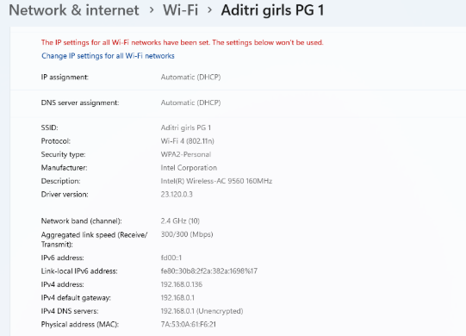
  - Network 2:
    - SSID: Aditri Girls 5G
    - Protocol / Band: Wi-Fi 5 (802.11ac) / 5 GHz (Channel 161)
    - Link Speed: 6000/6000 Kbps
    - Security Type: WPA2-Personal
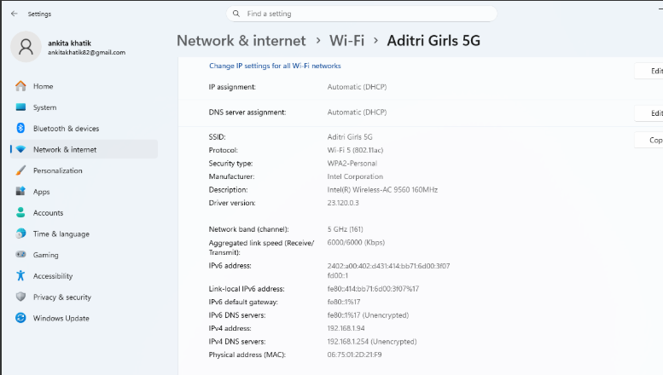
  - Network 3:
    - SSID: Aditri Girls
    - Protocol / Band: Wi-Fi 4 (802.11n) / 2.4 GHz (Channel 6)
    - Link Speed: 175/130 Mbps
    - Security Type: WPA2-Personal
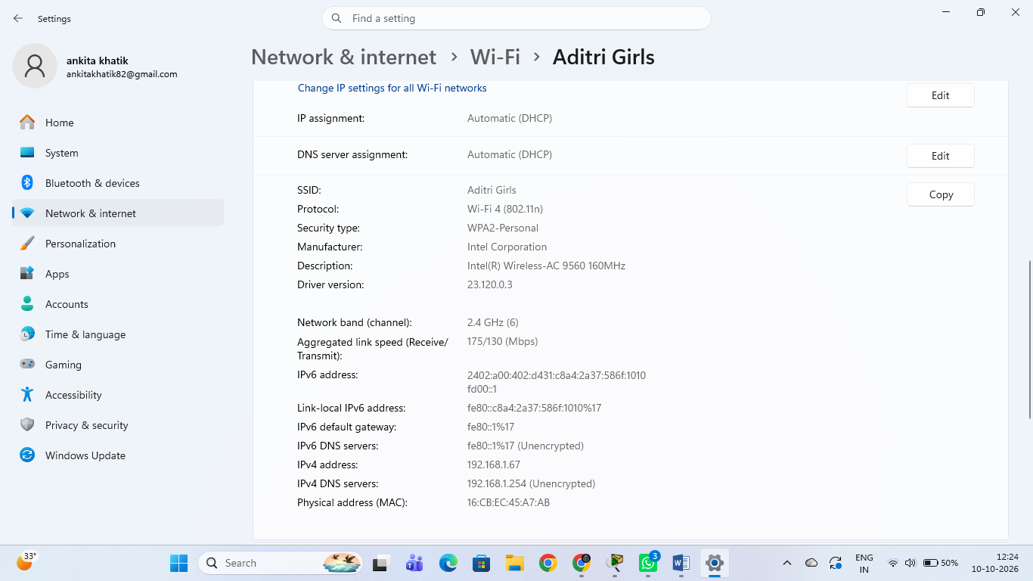
- Selection & Rationale:
  - Chosen Network: Aditri Girls 5G
  - Why: I would choose this network because it operates on the 5 GHz band using the Wi-Fi 5 (802.11ac) protocol, which typically experiences less interference, lower latency, and better data throughput compared to crowded 2.4 GHz bands. Additionally, it implements WPA2-Personal security, ensuring that data transmissions

4. Explain in your own words what 'SSID hiding' is in Wi-Fi networks and discuss one advantage and one disadvantage of hiding your Wi-Fi SSID.

SSID Hiding in Wi-Fi Networks
Meaning: SSID hiding means hiding the Wi-Fi network name from the list of available networks. Users usually need to enter the network name manually to connect.
Advantage: It makes the Wi-Fi network less visible to casual users nearby.
Disadvantage: It does not provide real security because the network name can still be discovered using network-scanning tools. It may also make connecting new devices less convenient.
Conclusion: Hiding the SSID alone is not enough to secure a Wi-Fi network. Using strong WPA2 or WPA3 security with a strong password is more important.

